User Manual

Before you reading the tutorial below , please ensure that you have installed the software to have a better understand.

User Interface

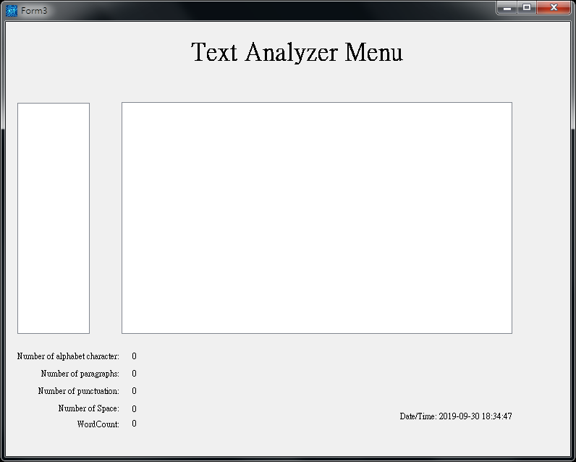

The thinner box is to show the file you have inputted into this system.

Another box is to show the content of the file you have inputted into this system.

The word below the thinner listbox is to show you the file’s paragraph,space,word …etc information

The word in the right-bottom corner is the current date.

If you double click the data time ,it will change into another type of timer.

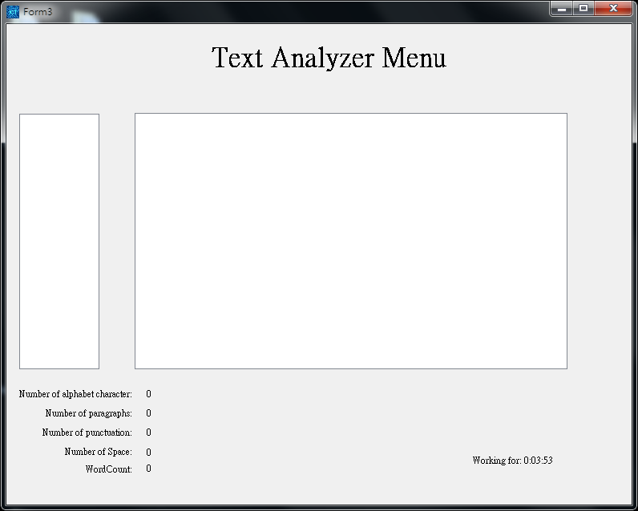

If you want to input some txt file, just double click in the bigger listbox ,you can select through the Directory Dialog.The whole file will be inputted to the system(subfiles also)

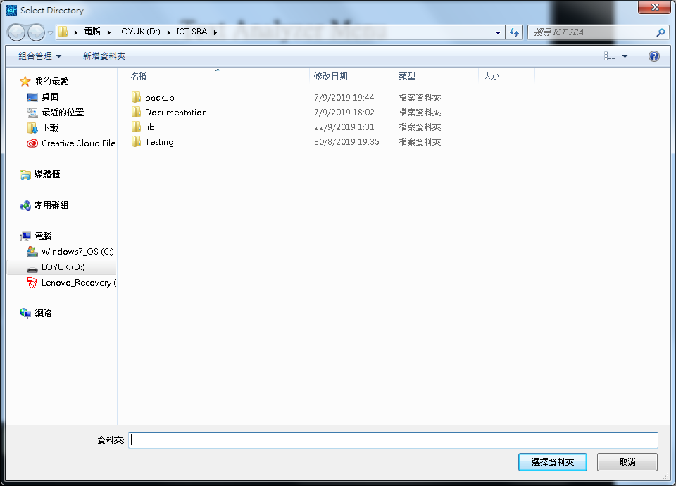

Just in case if you want a txt file only(not a whole folder), drag into the bigger box is OK.

After you have inputted the file, a new form will be created.

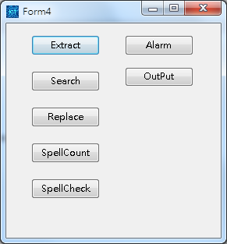

There are lots of function for you to use. We will tell you how to use those function in the below.

If you closed the function form and want to recall it back, just press ctrl + q . The form will display in the screen.

If the directory of the files is changed . You need to click the thinner list box to input again.

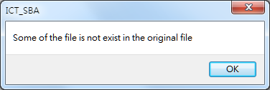

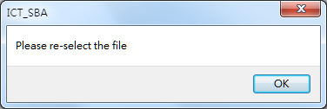

We can use mouse wheel to select the lines of the contents, ctrl + s to save the content into the file.

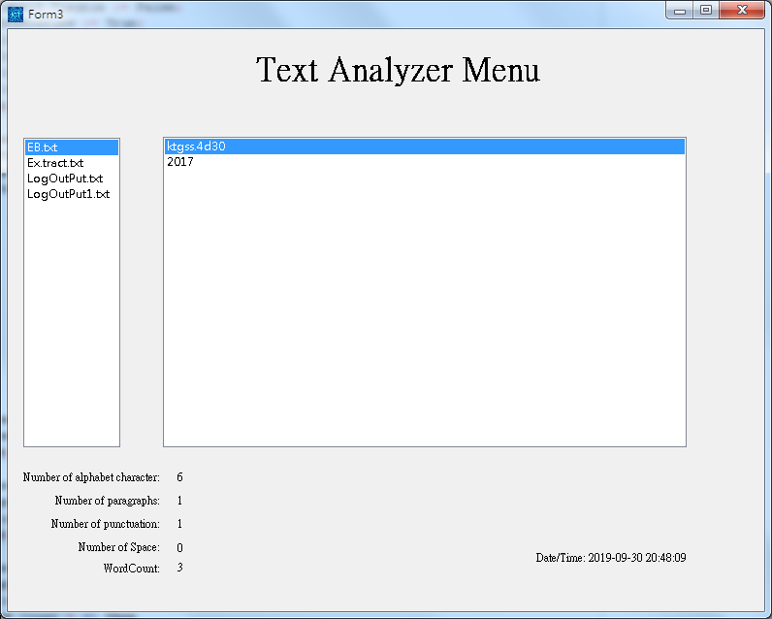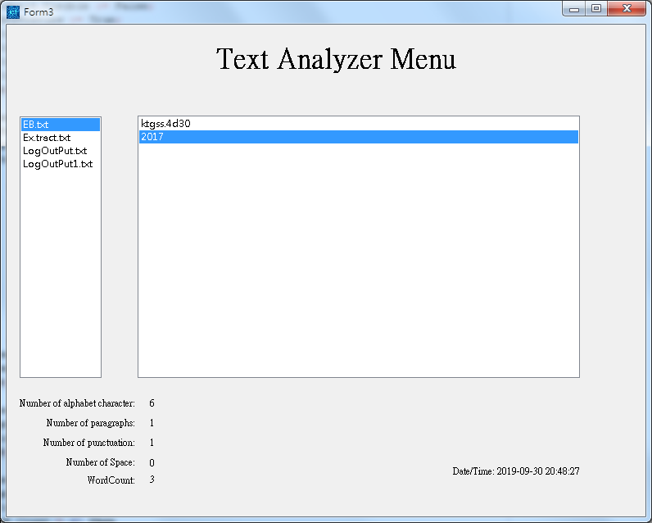

Before After

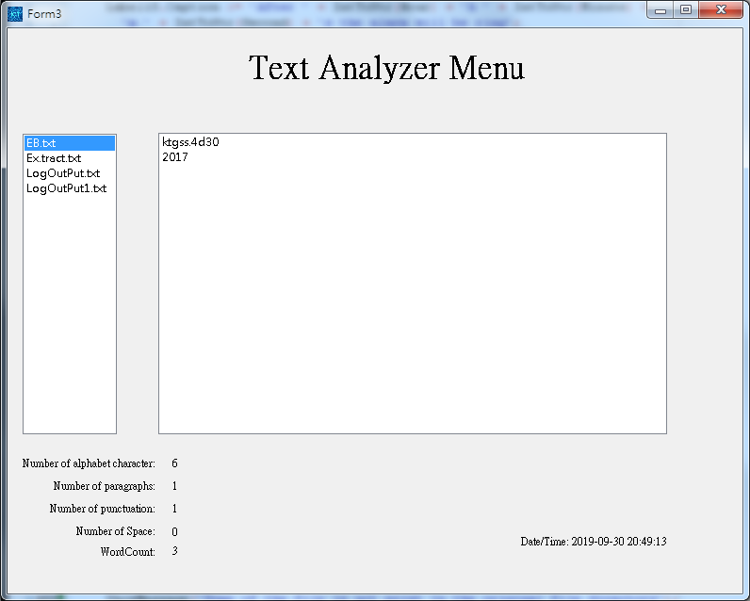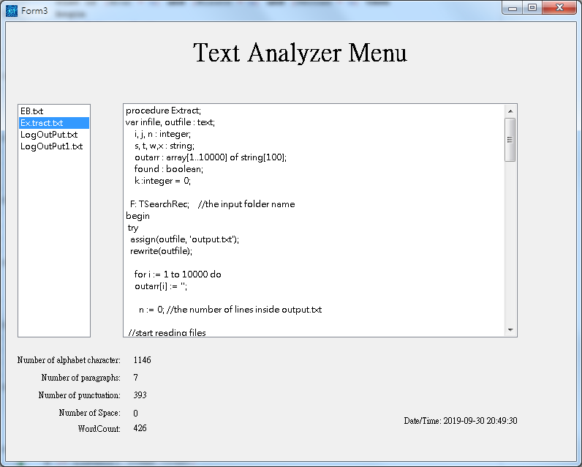

Before After

Double Click the thinner listbox can also input the folder

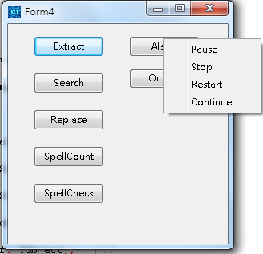

After right clicking the alarm button, it will pop up some selection .

Extract:

Short Version:

Click Extract and Select File.

Detailed Version:

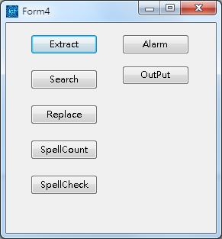

Click The blue one.

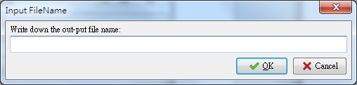

If you doesn’t enter the output file , the system will ask for using the default file name or exit the function .

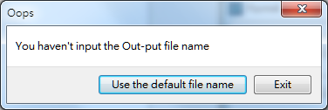

(Default file name :(Default.txt))

Input the output file name.

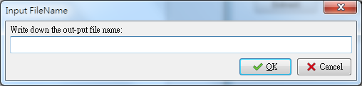

We can add the ‘.txt’ by manually or not , the system will add it for you automatically

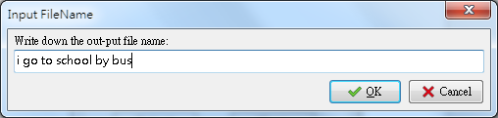

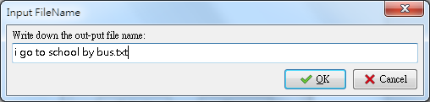

You can also input a ‘#’ to tell the system you want to select the folder by yourself

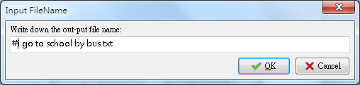

The Selection of directory will be displayed in the screen very soon.

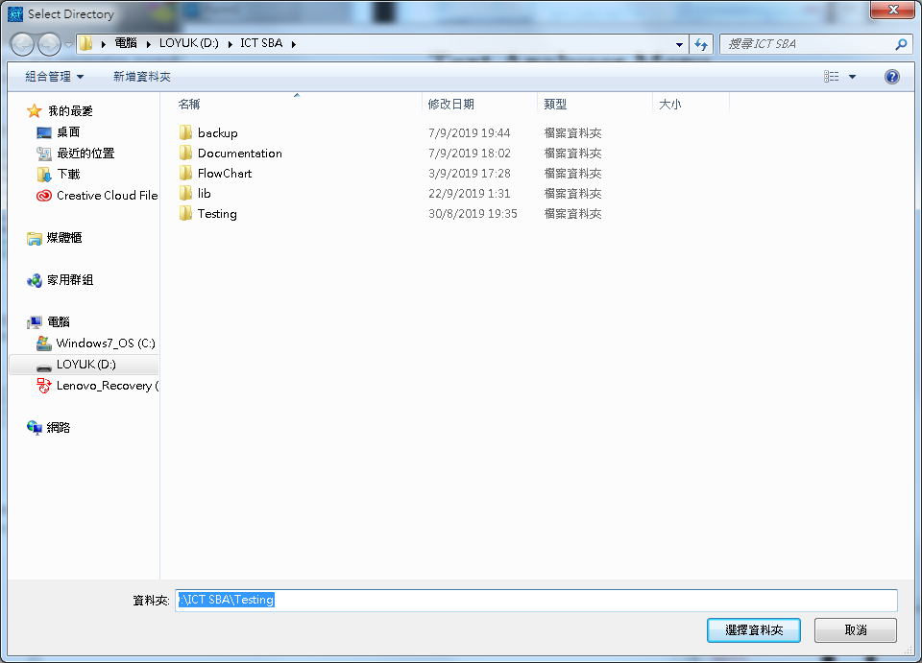

The system can only txt file only but the non-txt file inside the inputted file will not afftect the process of data.

After a moment , the success message will pop up to tell you the extracting is success or not

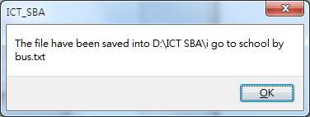

The output file will be sorted as ascending order and the numerical number in the text will not be saved into the output file.

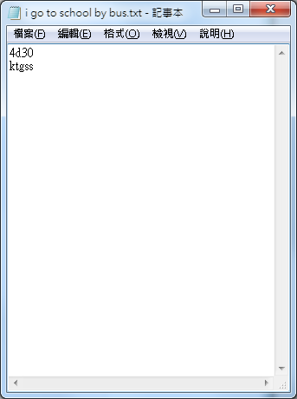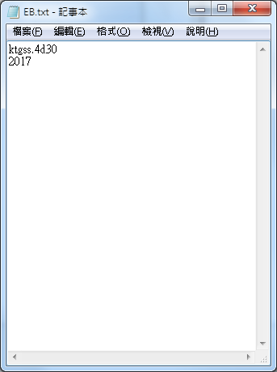

The original file The output file.

Search:

Short Version:

Click the Search button and enter the word you want to choose.

Detailed Version:

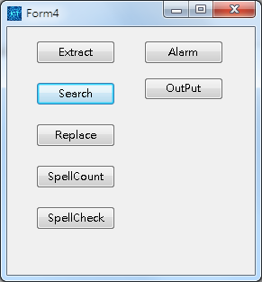

Click the blue one.

When the user pressed ‘Search’ , it will pop up a input box to input the answer.

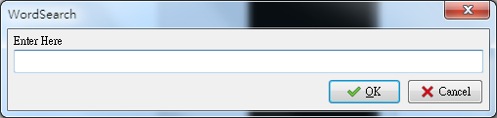

You can add a ‘#’ to represent a dependent word (e.g #add : eadde = False , add = True)

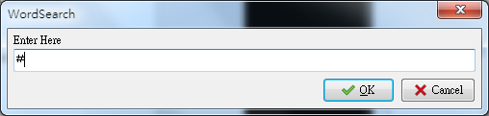

If a number of results had found, the program will display the count of the searched result

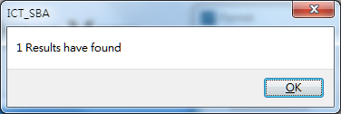

If no result has found , it will also output th0e message to you.

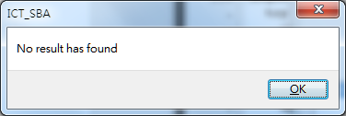

Example:

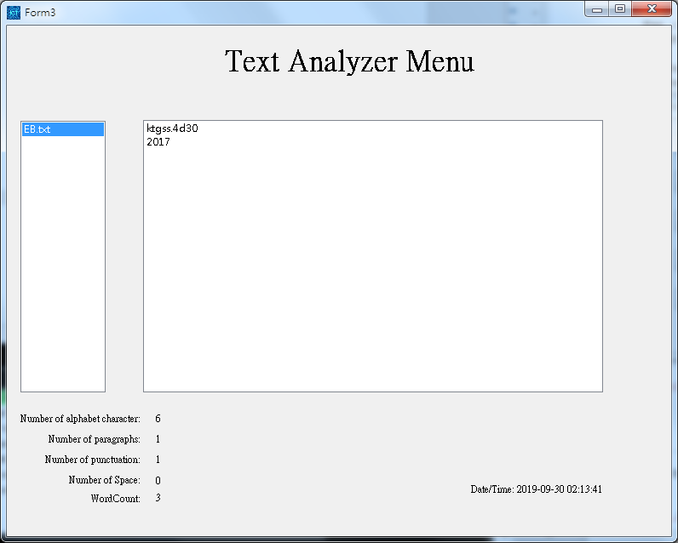

Test file

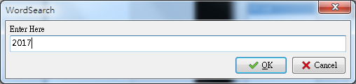

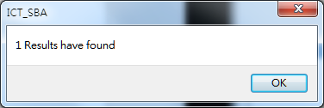

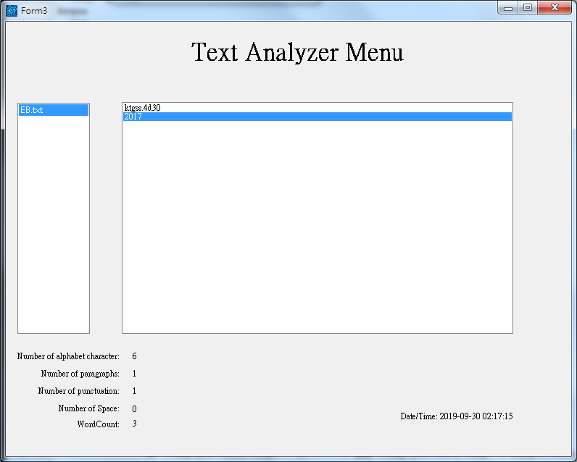

Replace

Short Version:

Click the replace button and enter the word !

Detailed Version:

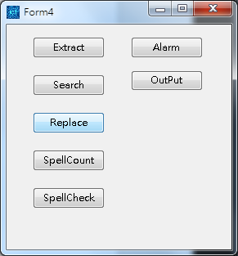

The blue button is ‘Replace’ Function

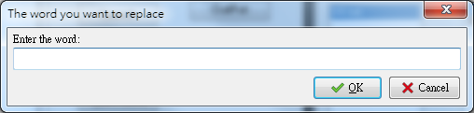

Enter the word you want to replace(Enter the word which is exist in the passage)(Eg.s)

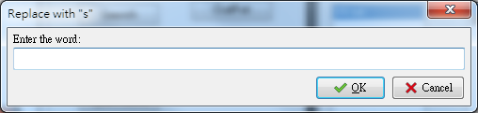

Enter the word you want to replace with(What do you want to change with?)(Eg.w)

If you input the word you want to replace only,the system will show a message to you.

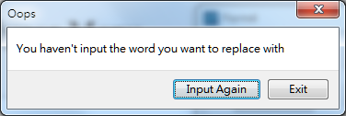

If you entered ‘exit’. You need to input all of the word again.

If you entered the same word in two of the input box.The system will tell you the word are inputted repeatedly.

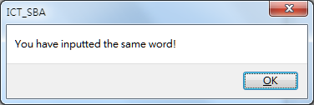

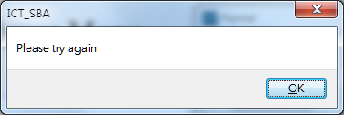

After replacing , the system will show the success dialog to user the replacing is finished

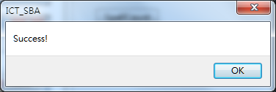

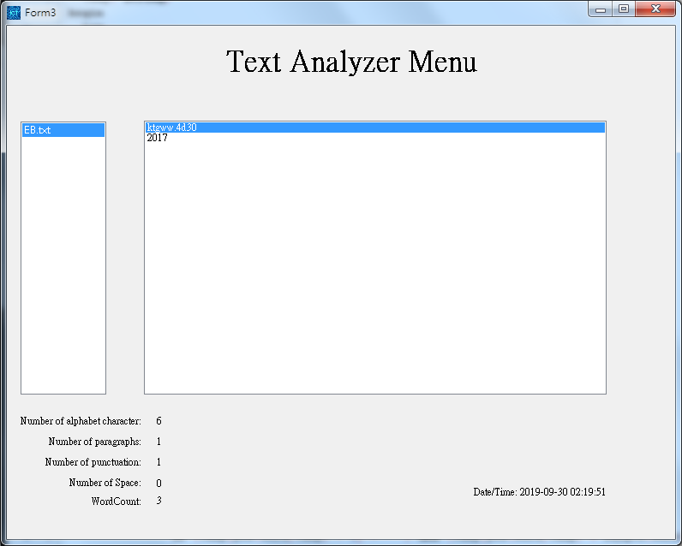

The line replaced will also highlight to tell the user there have some of the change .

No matter the system changed some of the word or not , the system will also display success to the user.

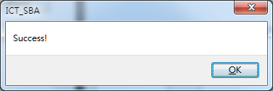

User can select the line they want to replace only.

(Please ensure had selected more than 2 Lines)

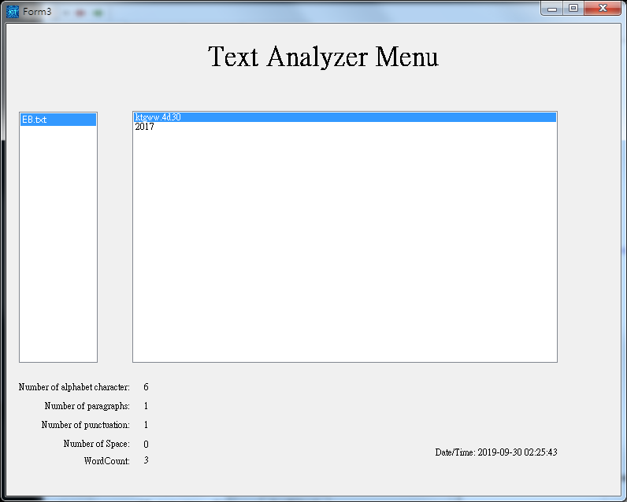

Like this

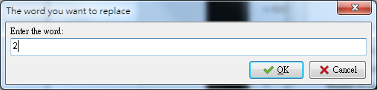

Use 2 to be the example

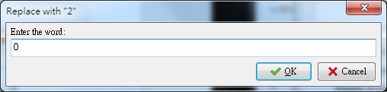

Use 0 to be the example.

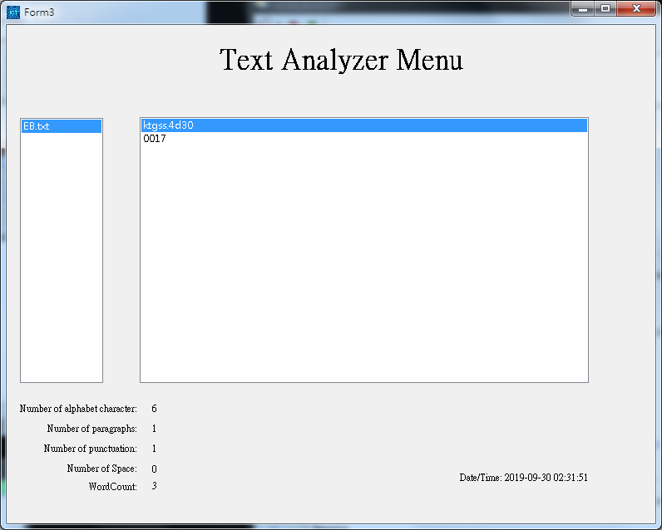

The ‘0’ will also be changed

SpellCount

Short Version:

Click the button and enter the word you want to count.

Detailed Version:

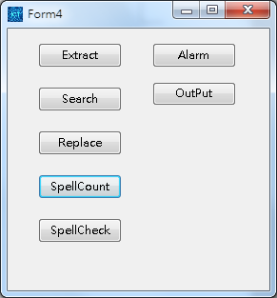

Click the blue one

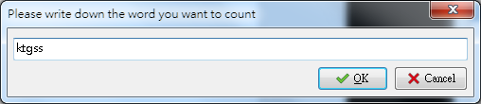

Please write down the word you want to count inside the inputbox

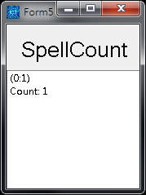

A new for m will be displayed out and it will show the location of the word that user want to count

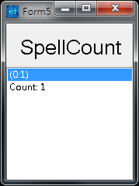

If we click the location of a word. The location in the bigger listbox will also be highlighted

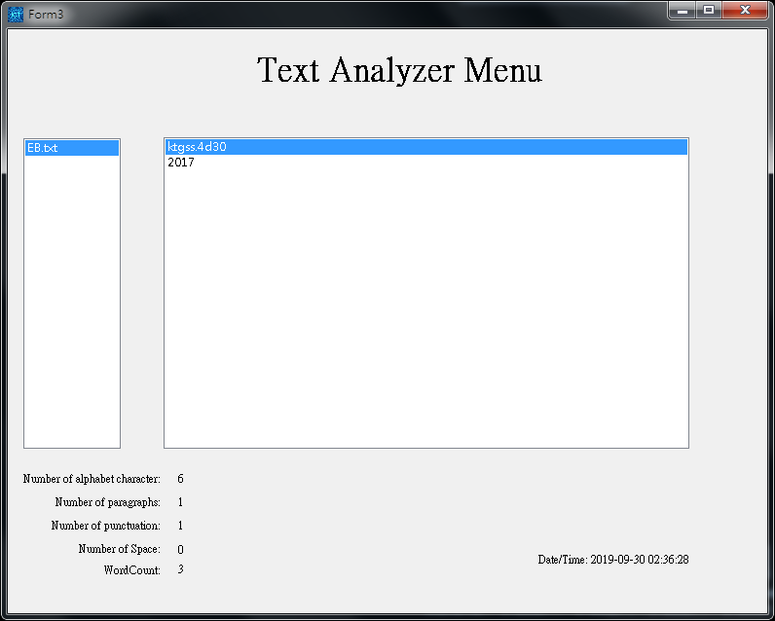

Just like this

SpellCheck

Short Version :

Click the SpellCheck button.

Detailed Version:

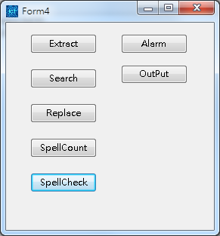

The blue one

After wait for a short period of time, a message will be displayed out

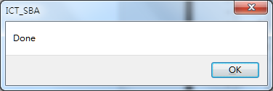

Show success of the function

If there is some mistakes in the text ,number of error will also show through dialog .

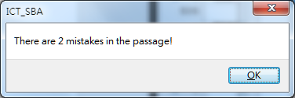

Also, a new form will be created

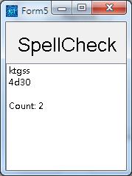

If you click the word in the ‘spellcheck’ form the error word will be highlighted in the bigger listbox.

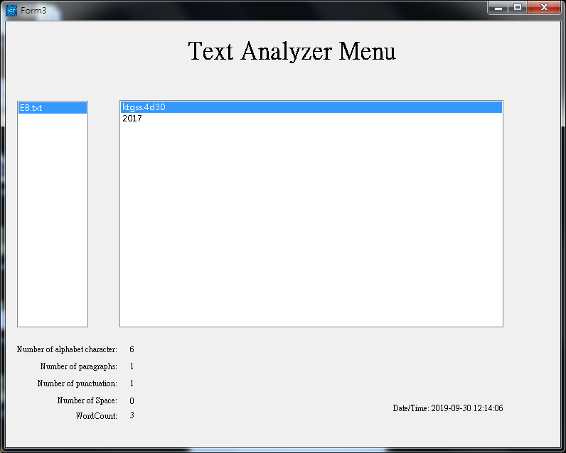

.Alarm

Short Version:

Enter the time you want to count.

Detailed Version:

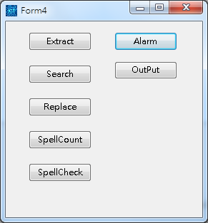

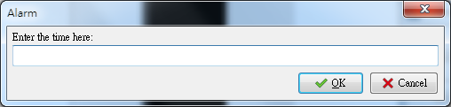

If you entered a constant, the system will consider as second to be the unit.

You can add a ‘:’ to represent minute /hour

Example : 3:50 = 3 minutes and 50 seconds

Also , input a constant which is greater than 60 is also OK , as the system will help you to change into a appropriate format automatically.

Output :

Short Version :

Just save the information of the file to a txt file.

Detailed Version:

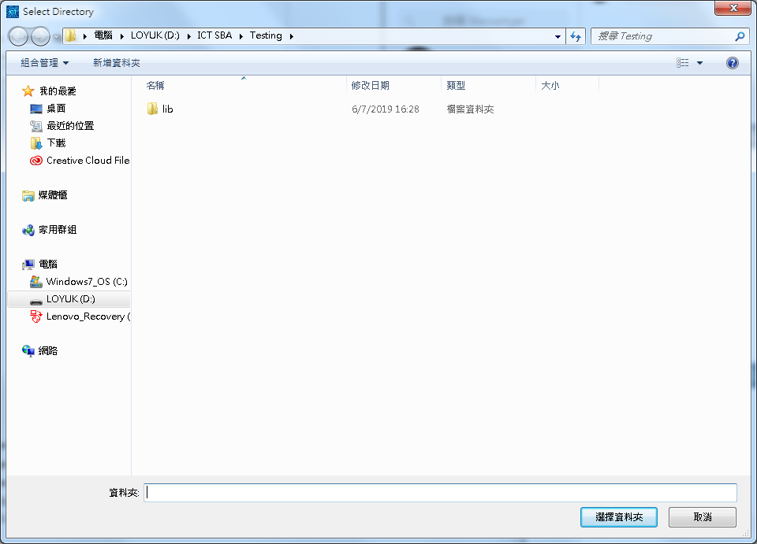

Select the file you want to save

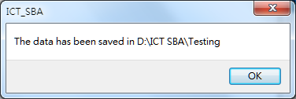

After finishing , the system will give you a message for validation.

Also , the record of different will not be replaced by the latest one.

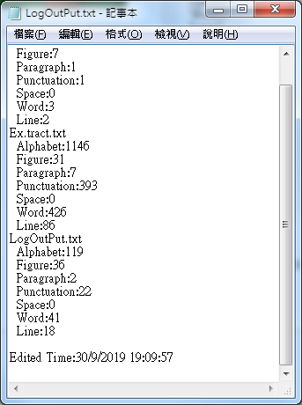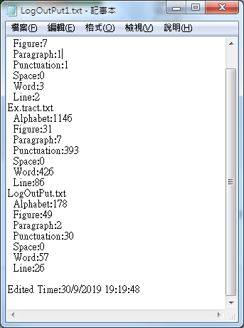

All of the information will be saved into here. Two of the txt is dependant with each other.